Diese Datei basiert auf der originalen Variablenbeschreibung AmesHousing.txt von kaggle.com. Zu Anfang werden einige praktische Abkürzungen und Übersetzungen gegeben. Weitere Erklärungen der Immobiliensprache siehe zum Beispiel unter www.gimme-shelter.com/category/term-2/

1st floor Paterre in USA

Alley street Seitengasse

Aterial street Hauptstrasse

Basement Keller

condo Wohnanlage

Cul-de-sac Sackgasse

Deed Urkunde

Deduction Abzug auf Preis wegen Mängel

Duplex Doppelwohneinheit

Dwelling Wohneinheit

feeder street Zubringerstrasse

Furnace Kamin, Ofen

Hip Dachgrat

Gravel Kies

Grvl Gravel

IA state Iowa, USA

Lot Parzelle, Flurstück

Mansard zum Wohnen ausgebauter Teil des Dachgeschosses

Masonry Mauerwerk

MS Market Survey

Paved geplastered

Plywood Sperrholz

Porch Veranda mit Dach

Shed Schuppen

Shingle Schieferplatte

Story Geschoss

Veneer Fassade, Furnier

Warranty deed Grundstücksübertragungsurkunde

Wood Deck Holzterrasse

Umrechnung 1 square feet = 0,092903 qm. Ungefähr 1 qm = 10,764 Quadratfuß

NAME: AmesHousing.txt

TYPE: Population

SIZE: 2930 observations, 82 variables

ARTICLE TITLE: Ames Iowa: Alternative to the Boston Housing Data Set

DESCRIPTIVE ABSTRACT: Data set contains information from the Ames Assessor’s Office used in computing assessed values for individual residential properties sold in Ames, IA from 2006 to 2010.

SOURCES: Ames, Iowa Assessor’s Office

VARIABLE DESCRIPTIONS:

Tab characters are used to separate variables in the data file. The data has 82 columns which include 23 nominal, 23 ordinal, 14 discrete, and 20 continuous variables (and 2 additional observation identifiers).

Order (Discrete): Observation number

PID (Nominal): Parcel identification number - can be used with city web site for parcel review.

MS SubClass (Nominal): Identifies the type of dwelling involved in the sale.

020 1-STORY 1946 & NEWER ALL STYLES

030 1-STORY 1945 & OLDER

040 1-STORY W/FINISHED ATTIC ALL AGES

045 1-1/2 STORY - UNFINISHED ALL AGES

050 1-1/2 STORY FINISHED ALL AGES

060 2-STORY 1946 & NEWER

070 2-STORY 1945 & OLDER

075 2-1/2 STORY ALL AGES

080 SPLIT OR MULTI-LEVEL

085 SPLIT FOYER

090 DUPLEX - ALL STYLES AND AGES (Doppelhäuser)

120 1-STORY PUD (Planned Unit Development) - 1946 & NEWER

150 1-1/2 STORY PUD - ALL AGES

160 2-STORY PUD - 1946 & NEWER

180 PUD - MULTILEVEL - INCL SPLIT LEV/FOYER

190 2 FAMILY CONVERSION - ALL STYLES AND AGES

MS Zoning (Nominal): Identifies the general zoning classification of the sale.

A Agriculture

C Commercial

FV Floating Village Residential

I Industrial

RH Residential High Density

RL Residential Low Density

RP Residential Low Density Park

RM Residential Medium Density

Lot Frontage (Continuous): Linear feet of street connected to property

Lot Area (Continuous): Lot size in square feet

Street (Nominal): Type of road access to property

Grvl Gravel

Pave Paved

Alley (Nominal): Type of alley access to property

Grvl Gravel

Pave Paved

NA No alley access

Lot Shape (Ordinal): General shape of property

Reg Regular

IR1 Slightly irregular

IR2 Moderately Irregular

IR3 Irregular

Land Contour (Nominal): Flatness of the property

Lvl Near Flat/Level

Bnk Banked - Quick and significant rise from street grade to building

HLS Hillside - Significant slope from side to side

Low Depression

Utilities (Ordinal): Type of utilities available

AllPub All public Utilities (E,G,W,& S)

NoSewr Electricity, Gas, and Water (Septic Tank)

NoSeWa Electricity and Gas Only

ELO Electricity only

Lot Config (Nominal): Lot configuration

Inside Inside lot

Corner Corner lot

CulDSac Cul-de-sac [Sackgasse]

FR2 Frontage on 2 sides of property

FR3 Frontage on 3 sides of property

Land Slope (Ordinal): Slope of property

Gtl Gentle slope

Mod Moderate Slope

Sev Severe Slope

Neighborhood (Nominal): Physical locations within Ames city limits (map available)

Blmngtn Bloomington Heights

Blueste Bluestem

BrDale Briardale

BrkSide Brookside

ClearCr Clear Creek

CollgCr College Creek

Crawfor Crawford

Edwards Edwards

Gilbert Gilbert

Greens Greens

GrnHill Green Hills

IDOTRR Iowa Department of Transportation (DOT) and Rail Road

Landmrk Landmark

MeadowV Meadow Village

Mitchel Mitchell

Names North Ames

NoRidge Northridge

NPkVill Northpark Villa

NridgHt Northridge Heights

NWAmes Northwest Ames

OldTown Old Town

SWISU South & West of Iowa State University

Sawyer Sawyer

SawyerW Sawyer West

Somerst Somerset

StoneBr Stone Brook

Timber Timberland

Veenker Veenker

Condition 1 (Nominal): Proximity to various conditions

Artery Adjacent to arterial street

Feedr Adjacent to feeder street

Norm Normal

RRNn Within 200' of North-South Railroad

RRAn Adjacent to North-South Railroad

PosN Near positive off-site feature--park, greenbelt, etc.

PosA Adjacent to postive off-site feature

RRNe Within 200' of East-West Railroad

RRAe Adjacent to East-West Railroad

Condition 2 (Nominal): Proximity to various conditions (if more than one is present)

Artery Adjacent to arterial street

Feedr Adjacent to feeder street

Norm Normal

RRNn Within 200' of North-South Railroad

RRAn Adjacent to North-South Railroad

PosN Near positive off-site feature--park, greenbelt, etc.

PosA Adjacent to postive off-site feature

RRNe Within 200' of East-West Railroad

RRAe Adjacent to East-West Railroad

Bldg Type (Nominal): Type of dwelling (Wohnhaus)

1Fam Single-family Detached

2FmCon Two-family Conversion; originally built as one-family dwelling

Duplx Duplex (Doppelhaus)

TwnhsE Townhouse End Unit (Reihenhaus)

TwnhsI Townhouse Inside Unit

House Style (Nominal): Style of dwelling

1Story One story

1.5Fin One and one-half story: 2nd level finished

1.5Unf One and one-half story: 2nd level unfinished

2Story Two story

2.5Fin Two and one-half story: 2nd level finished

2.5Unf Two and one-half story: 2nd level unfinished

SFoyer Split Foyer

SLvl Split Level

Overall Qual (Ordinal): Rates the overall material and finish of the house

10 Very Excellent

9 Excellent

8 Very Good

7 Good

6 Above Average

5 Average

4 Below Average

3 Fair

2 Poor

1 Very Poor

Overall Cond (Ordinal): Rates the overall condition of the house

10 Very Excellent

9 Excellent

8 Very Good

7 Good

6 Above Average

5 Average

4 Below Average

3 Fair

2 Poor

1 Very Poor

Year Built (Discrete): Original construction date

Year Remod/Add (Discrete): Remodel date (same as construction date if no remodeling or additions)

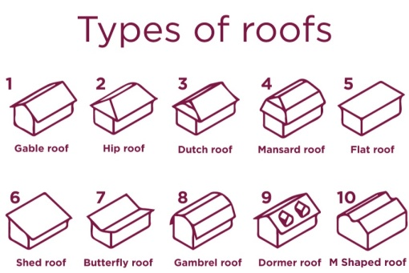Roof Style (Nominal): Type of roof

Flat Flat

Gable Gable [Satteldach, Giebeldach]

Gambrel Gambrel (Barn) [Wagendach]

Hip Hip [Walmdach]

Mansard Mansard [Mansardendach]

Shed Shed [Sägezahn-, Pult-, Halbdach]

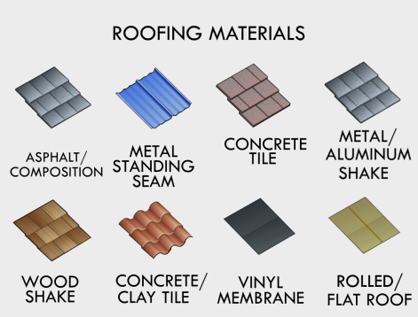Roof Matl (Nominal): Roof material

ClyTile Clay or Tile

CompShg Standard (Composite) Shingle

Membran Membrane

Metal Metal

Roll Roll

Tar&Grv Gravel & Tar

WdShake Wood Shakes

WdShngl Wood Shingles

Exterior 1 (Nominal): Exterior covering on house

AsbShng Asbestos Shingles (Asbestschieferplatte)

AsphShn Asphalt Shingles

BrkComm Brick Common

BrkFace Brick Face (Verblendziegel)

CBlock Cinder Block (Betonhohlstein)

CemntBd Cement Board (Betonplatte)

HdBoard Hard Board

ImStucc Imitation Stucco

MetalSd Metal Siding

Other Other

Plywood Plywood (Sperrholz)

PreCast PreCast (Betonfertigteil)

Stone Stone

Stucco Stucco

VinylSd Vinyl Siding (Kunststoffverkleidung)

Wd Sdng Wood Siding

WdShing Wood Shingles

Exterior 2 (Nominal): Exterior covering on house (if more than one material)

AsbShng Asbestos Shingles

AsphShn Asphalt Shingles

BrkComm Brick Common

BrkFace Brick Face

CBlock Cinder Block

CemntBd Cement Board

HdBoard Hard Board

ImStucc Imitation Stucco

MetalSd Metal Siding

Other Other

Plywood Plywood

PreCast PreCast

Stone Stone

Stucco Stucco

VinylSd Vinyl Siding

Wd Sdng Wood Siding

WdShing Wood Shingles

Mas Vnr Type (Nominal): Masonry veneer type (Mauerverblendung)

BrkCmn Brick Common

BrkFace Brick Face

CBlock Cinder Block

None None

Stone Stone

Mas Vnr Area (Continuous): Masonry veneer area in square feet

Exter Qual (Ordinal): Evaluates the quality of the material on the exterior

Ex Excellent

Gd Good

TA Average/Typical

Fa Fair

Po Poor

Exter Cond (Ordinal): Evaluates the present condition of the material on the exterior

Ex Excellent

Gd Good

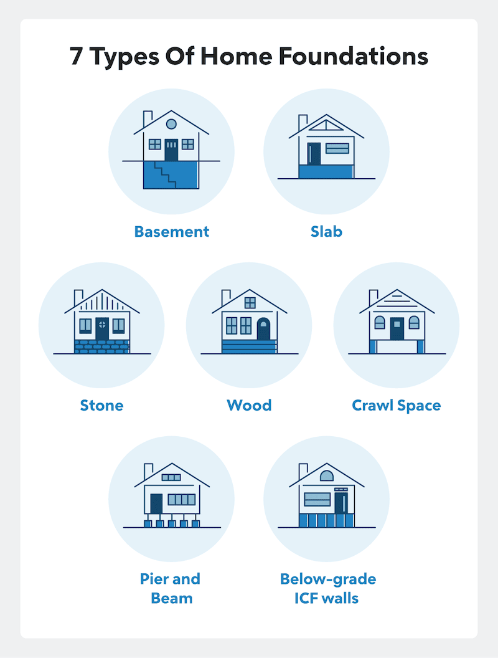 TA Average/Typical

Fa Fair

Po Poor

Foundation (Nominal): Type of foundation

BrkTil Brick & Tile

CBlock Cinder Block

PConc Poured Contrete

Slab Slab

Stone Stone

Wood Wood

Bsmt Qual (Ordinal): Evaluates the height of the basement

Ex Excellent (100+ inches)

Gd Good (90-99 inches)

TA Typical (80-89 inches)

Fa Fair (70-79 inches)

Po Poor (<70 inches

NA No Basement

Bsmt Cond (Ordinal): Evaluates the general condition of the basement

Ex Excellent

Gd Good

TA Typical - slight dampness allowed

Fa Fair - dampness or some cracking or settling

Po Poor - Severe cracking, settling, or wetness

NA No Basement

Bsmt Exposure (Ordinal): Refers to walkout or garden level walls

Gd Good Exposure

Av Average Exposure (split levels or foyers typically score average or above)

Mn Mimimum Exposure

No No Exposure

NA No Basement

BsmtFin Type 1 (Ordinal): Rating of basement finished area

GLQ Good Living Quarters

ALQ Average Living Quarters

BLQ Below Average Living Quarters

Rec Average Rec Room

LwQ Low Quality

Unf Unfinshed

NA No Basement

BsmtFin SF 1 (Continuous): Type 1 finished square feet

BsmtFinType 2 (Ordinal): Rating of basement finished area (if multiple types)

GLQ Good Living Quarters

ALQ Average Living Quarters

BLQ Below Average Living Quarters

Rec Average Rec Room

LwQ Low Quality

Unf Unfinshed

NA No Basement

BsmtFin SF 2 (Continuous): Type 2 finished square feet

Bsmt Unf SF (Continuous): Unfinished square feet of basement area

Total Bsmt SF (Continuous): Total square feet of basement area

Heating (Nominal): Type of heating

Floor Floor Furnace (Fußbodenwarmluftheizung)

GasA Gas forced warm air furnace

GasW Gas hot water or steam heat

Grav Gravity furnace (Innenwarmluftheizung)

OthW Hot water or steam heat other than gas

Wall Wall furnace (Außenwandwarmluftheizung)

HeatingQC (Ordinal): Heating quality and condition

Ex Excellent

Gd Good

TA Average/Typical

Fa Fair

Po Poor

Central Air (Nominal): Central air conditioning

N No

Y Yes

Electrical (Ordinal): Electrical system

SBrkr Standard Circuit Breakers & Romex

FuseA Fuse Box over 60 AMP and all Romex wiring (Average)

FuseF 60 AMP Fuse Box and mostly Romex wiring (Fair)

FuseP 60 AMP Fuse Box and mostly knob & tube wiring (poor)

Mix Mixed

1st Flr SF (Continuous): First Floor square feet

2nd Flr SF (Continuous) : Second floor square feet

Low Qual Fin SF (Continuous): Low quality finished square feet (all floors)

Gr Liv Area (Continuous): Above grade (ground) living area square feet

Bsmt Full Bath (Discrete): Basement full bathrooms

Bsmt Half Bath (Discrete): Basement half bathrooms

Full Bath (Discrete): Full bathrooms above grade

Half Bath (Discrete): Half baths above grade

Bedroom (Discrete): Bedrooms above grade (does NOT include basement bedrooms)

Kitchen (Discrete): Kitchens above grade

KitchenQual (Ordinal): Kitchen quality

Ex Excellent

Gd Good

TA Typical/Average

Fa Fair

Po Poor

TotRmsAbvGrd (Discrete): Total rooms above grade (does not include bathrooms)

Functional (Ordinal): Home functionality (Assume typical unless deductions are (Abstriche) warranted)

Typ Typical Functionality

Min1 Minor Deductions 1

Min2 Minor Deductions 2

Mod Moderate Deductions

Maj1 Major Deductions 1

Maj2 Major Deductions 2

Sev Severely Damaged

Sal Salvage only (nur Abbruch möglich)

Fireplaces (Discrete): Number of fireplaces

FireplaceQu (Ordinal): Fireplace quality

Ex Excellent - Exceptional Masonry Fireplace

Gd Good - Masonry Fireplace in main level

TA Average - Prefabricated Fireplace in main living area or Masonry Fireplace in basement

Fa Fair - Prefabricated Fireplace in basement

Po Poor - Ben Franklin Stove

NA No Fireplace

Garage Type (Nominal): Garage location

2Types More than one type of garage

Attchd Attached to home

Basment Basement Garage

BuiltIn Built-In (Garage part of house - typically has room above garage)

CarPort Car Port

Detchd Detached from home

NA No Garage

Garage Yr Blt (Discrete): Year garage was built

Garage Finish (Ordinal) : Interior finish of the garage

Fin Finished

RFn Rough Finished

Unf Unfinished

NA No Garage

Garage Cars (Discrete): Size of garage in car capacity

Garage Area (Continuous): Size of garage in square feet

Garage Qual (Ordinal): Garage quality

Ex Excellent

Gd Good

TA Typical/Average

Fa Fair

Po Poor

NA No Garage

Garage Cond (Ordinal): Garage condition

Ex Excellent

Gd Good

TA Typical/Average

Fa Fair

Po Poor

NA No Garage

Paved Drive (Ordinal): Paved driveway

Y Paved

P Partial Pavement

N Dirt/Gravel

Wood Deck SF (Continuous): Wood deck area in square feet

Open Porch SF (Continuous): Open porch area in square feet

Enclosed Porch (Continuous): Enclosed porch area in square feet

3-Ssn Porch (Continuous): Three season porch area in square feet

Screen Porch (Continuous): Wintergarten area in square feet

Pool Area (Continuous): Pool area in square feet

Pool QC (Ordinal): Pool quality

Ex Excellent

Gd Good

TA Average/Typical

Fa Fair

NA No Pool

Fence (Ordinal): Fence quality

GdPrv Good Privacy

MnPrv Minimum Privacy

GdWo Good Wood

MnWw Minimum Wood/Wire

NA No Fence

Misc Feature (Nominal): Miscellaneous feature not covered in other categories

Elev Elevator

Gar2 2nd Garage (if not described in garage section)

Othr Other

Shed Shed (over 100 SF)

TenC Tennis Court

NA None

Misc Val (Continuous): $Value of miscellaneous feature

Mo Sold (Discrete): Month Sold (MM)

Yr Sold (Discrete): Year Sold (YYYY)

Sale Type (Nominal): Type of sale

Siehe https://www.wf-frank.com/glossar/def/warranty-deed.html

WD Warranty Deed – Conventional (Übertragungsurkunde mit Garantien)

CWD Warranty Deed - Cash

VWD Warranty Deed - VA Loan

New Home just constructed and sold

COD Court Officer Deed/Estate

Con Contract 15% Down payment regular terms

ConLw Contract Low Down payment and low interest

ConLI Contract Low Interest (Hypothek mit günstigem Zinssatz)

ConLD Contract Low Down

Oth Other

Sale Condition (Nominal): Condition of sale

Normal Normal Sale

Abnorml Abnormal Sale - trade, foreclosure (Zwangsvollstreckung), short sale (ohne

Hypotheken)

AdjLand Adjoining Land Purchase

Alloca Allocation - two linked properties with separate deeds, typically condo with a garage

unit

Family Sale between family members

Partial Home was not completed when last assessed (associated with New Homes)

SalePrice (Continuous): Sale price $$

SPECIAL NOTES:

There are 5 observations that an instructor may wish to remove from the data set before giving it to students (a plot of SALE PRICE versus GR LIV AREA will indicate them quickly). Three of them are true outliers (Partial Sales that likely don’t represent actual market values) and two of them are simply unusual sales (very large houses priced relatively appropriately). I would recommend removing any houses with more than 4000 square feet from the data set (which eliminates these 5 unusual observations) before assigning it to students.

STORY BEHIND THE DATA:

This data set was constructed for the purpose of an end of semester project for an undergraduate regression course.

The original data (obtained directly from the Ames Assessor’s Office) is used for tax assessment purposes but lends itself directly to the prediction of home selling prices. The type of information contained in the data is similar to what a typical home buyer would want to know before making a purchase and students should find most variables straightforward and understandable.

PEDAGOGICAL NOTES:

Instructors unfamiliar with multiple regression may wish to use this data set in conjunction with an earlier JSE paper that reviews most of the major issues found in regression modeling:

Kuiper , S. (2008), “Introduction to Multiple Regression: How Much Is Your Car Worth?”, Journal of Statistics Education, Volume 16, Number 3 (2008).

Outside of the general issues associated with multiple regression discussed in this article, this particular data set offers several opportunities to discuss how the purpose of a model might affect the type of modeling done. User of this data may also want to review another JSE article related directly to real estate pricing:

Pardoe , I. (2008), “Modeling home prices using realtor data”, Journal of Statistics Education Volume 16, Number 2 (2008).

One issue is in regards to homoscedasticity and assumption violations. The graph included in the article appears to indicate heteroscedasticity with variation increasing with sale price and this problem is evident in many simple home pricing models that focus only on house and lot sizes. Though this violation can be alleviated by transforming the response variable (sale price), the resulting equation yields difficult to interpret fitted values (selling price in log or square root dollars). This situation gives the instructor the opportunity to talk about the costs (biased estimators, incorrect statistical tests, etc.) and benefits (ease of use) of not correcting this assumption violation. If the purpose in building the model is simply to allow a typical buyer or real estate agent to sit down and estimate the selling price of a house, such transformations may be unnecessary or inappropriate for the task at hand. This issue could also open into a discussion on the contrasts and comparisons between data mining, predictive models, and formal statistical inference.

A second issue closely related to the intended use of the model, is the handling of outliers and unusual observations. In general, I instruct my students to never throw away data points simply because they do not match a priori expectations (or other data points). I strongly make this point in the situation where data are being analyzed for research purposes that will be shared with a larger audience. Alternatively, if the purpose is to once again create a common use model to estimate a “typical” sale, it is in the modeler’s best interest to remove any observations that do not seem typical (such as foreclosures or family sales).

REFERENCES:

Individual homes within the data set can be referenced directly from the Ames City Assessor webpage via the Parcel ID (PID) found in the data set. Note these are nominal values (non-numeric) so preceding 0’s must be included in the data entry field on the website. Access to the database can be gained from the Ames site (http://www.cityofames.org/assessor/) by clicking on “property search” or by accessing the Beacon (http://beacon.schneidercorp.com/Default.aspx) website and inputting Iowa and Ames in the appropriate fields. A city map showing the location of all the neighborhoods is also available on the Ames site and can be accessed by clicking on “Maps” and then “Residential Assessment Neighborhoods (City of Ames Only)”.

SUBMITTED BY:

Dean De Cock

Truman State University

100 E. Normal St., Kirksville, MO, 63501

decock@truman.edu